Why is Mary I known as ‘Bloody Mary’?
Tudor Religion Lesson 6 Name: ___________
Use the relevant webpage on www.mrluptonhistory.co.uk to help you complete the work for today’s lesson.

STARTER:
Edward died in 1553, leaving his Catholic sister Mary to rule England. Edward had turned the Church in to a very Protestant Church during his reign, yet Mary was about to change that.
Look at the Church items below. Can you list which ones would have been preferred by Edward and which ones would have been preferred by Mary?
HINT: Think about which items are Protestant and which items are Catholic to decide.

Item | Image | Preferred by Edward or Mary? | Why?
The bible in English | 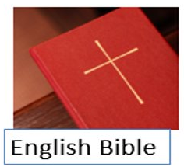 | Edward | Because having an English bible was a Protestant belief
The bible in Latin | 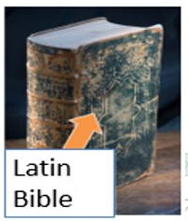
The monarch is the head of the Church | 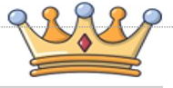
The Pope is the head of the Church | 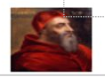
Decorated crucifix | 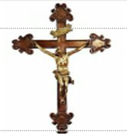
Plain crucifix | 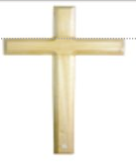

TASK ONE: How easy would it be for Mary to change the Church back to Catholicism?
Read through the facts below on the state of the Church in England at the beginning of Mary's reign. For each fact, think about if it will help Mary change the Church back to Catholicism, or if it will hinder (prevent) her from changing it back to Catholicism.

Fact | Help | Hinder
England had only been a Protestant country for six years, while her brother Edward was King most people had been brought up as a Catholic and were used to the Catholic religion. | x
Monasteries were important to Catholics, but Henry VIII had closed them all down and sold their land to important families to raise money to fight wars.

There was a large group of Protestants in England who hated Catholicism and would never agree to go back to it.

Mary was 37 and had no children when she became Queen, the next person in line to the throne was Elizabeth. Elizabeth was a Protestant.

Four hundred of the most famous Protestant leaders ran away to Europe as soon as they heard Mary had become Queen.

When Mary had become Queen people were very happy, a few Protestants had tried to rebel against her, but no one supported them.

CHALLENGE: When looking at the facts above, overall, how easy do you think it would be for Mary to change the English Church back to Catholicism? Why?
ANSWER:

TASK TWO: How did Mary try to change the Church back to Catholicism?
Read the timeline below on how Mary tried to change the Church back to Catholicism. For each part, tick the box to state if each one shows a completely successful change back to Catholicism, only a partial change back to Catholicism, or if Mary failed to make a change to the Church at all.

Date | Event | Mary successfully made Catholic changes | Slightly successful change | Mary could not turn England to Catholicism
August 1553 | As soon as Mary took the throne from her brother, she arrested lots of important Protestant church people. | x
Autumn 1553 | Mary removed all the Protestant laws that Edward VI had put in place before her.
December 1553 | Mary made the Pope the Head of the Church.
January 1554 | About 800 Protestants leave to go to Germany as they are worried for their safety under Mary I.
April 1554 | Mary I is stopped from giving back land to the Church by her nobles. The Catholic Church relied on having lots of land to make money.
November 1554 | The Pope allows England to be part of the Catholic community again, but the Pope does not completely accept England as he didn’t like Mary I’s husband.
February 1555 | Lots of Protestants are burned alive by Mary as they pose a threat to her.
June 1557 | Some small monasteries (buildings housing Catholic church people like monks and nuns) were rebuilt. However, this was only a tiny number compared to the 800 that Henry VIII had shut down a few decades before her.
November 1558 | Mary I died without a child. Her Protestant sister Elizabeth took the throne. It looked as though England was about to become Protestant once again.

TASK THREE: What kind of change did Mary I make to the English Church?
Look at the key word box below.

Can you pick out two types of changes that Mary made to the English Church? You only need to write these as a couple of short sentences.
I think Mary made a ____ change to the English Church. This is because... (include evidence that you found in Task Two).
I also think Mary made a ____ change to the English Church. This is because... (include evidence that you found in Task Two).

Change and continuity - Key Word Box
Complete change = When everything changes completely.
Partial change = When some things change, but other things stay the same.
Dramatic change = When the change is very different to what came before.
Temporary change = When something changes, but only for a short while.
Immediate change = When something changes instantly.

ANSWER:

