How far did Edward VI transform the Church of England?
Tudor religion, lesson 4 Name: __________________
Use the relevant webpage on www.mrluptonhistory.co.uk to complete the work for today’s lesson.

STARTER: What can you tell from the painting?
Look at the painting below: it is dated from the time when Edward VI came to the throne in 1547. Each part of the picture has a label – can you link up each label to the correct description in the blue box?
Can you use this information to answer the question below the blue box?

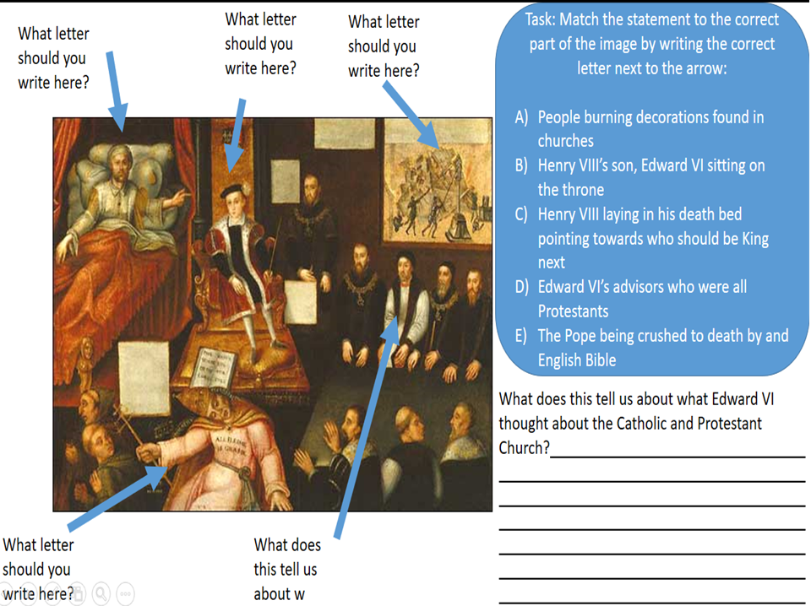

ANSWERS:

TASK ONE: How much change do you think Edward could make in his reign?
Edward VI became King when he was only 9 years old when his father, Henry VIII, died in 1547. He was raised a Protestant so started to transform the Church. However, he died by the time he was 15 in 1553, so only had 6 years to make the changes.​
How much do you think a 9 year old boy can change over 6 years? Write a sentence and explain why you believe this.

ANSWER:

TASK TWO: How far did Edward VI change the Church?
Read the information on the changes that Edward VI made to the Church of England on the webpage. After you have finished reading the information, answer the questions:
1) Was this a transformation compared to his father? Compared to his father, Edward completely transformed the church / made some changes to the church / slightly altered the church / kept it the same as Henry’s church. I think this because…
2) Were the people Protestant or Catholic? What does that reveal to us about whether Edward really transformed religion? The people were Protestant / Catholic / some were Protestant and Catholic. This shows that Edward did/did not transform the Church because…

ANSWERS:
1)

2)

TASK THREE: The Church of England – Space Invaders!
We have now seen what both Henry VIII and Edward VI did to the churches in England. Have a look at what the churches would have looked like for the three types of churches on the webpage.
1) A Catholic Church
2) Henry VIII’s Church
3) Edward VI’s Church
Remember what they look like and then try to complete the video game in the link below – you need to remember their details to do well at the game!

Think you’ve remembered all you can about the Churches below and the details of today’s lesson? Click here to play Space Invaders!

https://www.classtools.net/space/202005_XmKMj2

