Why was religion significant in the Tudor period?
Tudors Lesson 1 Name: ________________________
Please use the relevant webpage on www.mrluptonhistory.co.uk to answer the worksheet.

STARTER:
Look at the image on the webpage.
1) Who might the men be in the centre of the picture?
2) Why might they be covered in straw?
3) Therefore, what do you believe is happening in this picture?

TASK ONE: Who were the kings and queens of the Tudor period?
a) Look at the picture and boxes below on the timeline of the kings and queens of England. Look up their names and the dates that they ruled England from and until.
b) Do you know any interesting facts about any of these people? Bullet point anything you already know about any of these kings and queens.
-

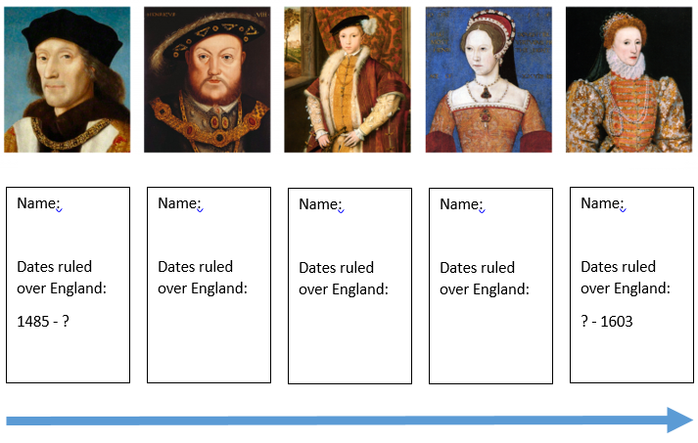
TASK TWO: What were the differences between Catholicism and Protestantism?
Read the information on the webpage and look at the table below.

For each box, decide if the belief is a Catholic belief, a Protestant belief or if both religions hold the belief. The first one has been done for you.

The Bible should be in your own language.  Answer: Protestantism | There should be plain, simple clothes for priests.  Answer: | Priests should wear highly-decorated vestments (clothes for priests).  Answer:
The ruler of the country should be the Head of the Church.  Answer: | Bread and wine are only symbols of Christ’s body and blood.  Answer: | The Pope should be the head of the Church.  Answer:
Ordinary people do not need priests, bishops or cardinals to find God.  Answer: | Bread and wine can be miraculously transformed into the body and blood of Christ at a service called Mass.  Answer: | Monks, bishops, cardinals and the Pope are God’s special representatives on Earth.  Answer:
Churches should be simply decorated and should not distract from God.  Answer: | Churches should be decorated with gold plates, crucifixes and powerful images to display the greatness of God.  Answer:

CHALLENGE QUESTION:
Christianity had not changed for over a thousand years until the introduction of Protestantism in the early 1500s, splitting people into two different religions across Europe.
What consequences do you think this may have had? Do you think people would have gotten on despite following a different religion? Use the starter image and the key words from this lesson to help you with your answer.

