End of Spring Term assessment – Year 10
Nazi Germany Key Topic 2, lesson 9 Name: _____________________
QUESTION 1: Give two things you can infer from Source A about the early developments of the Nazi Party.
[4 marks]

Source A: A painting by Hermann Hoyer. It is entitled ‘in the beginning there was the word’ and shows Hitler addressing a party meeting in 1921.
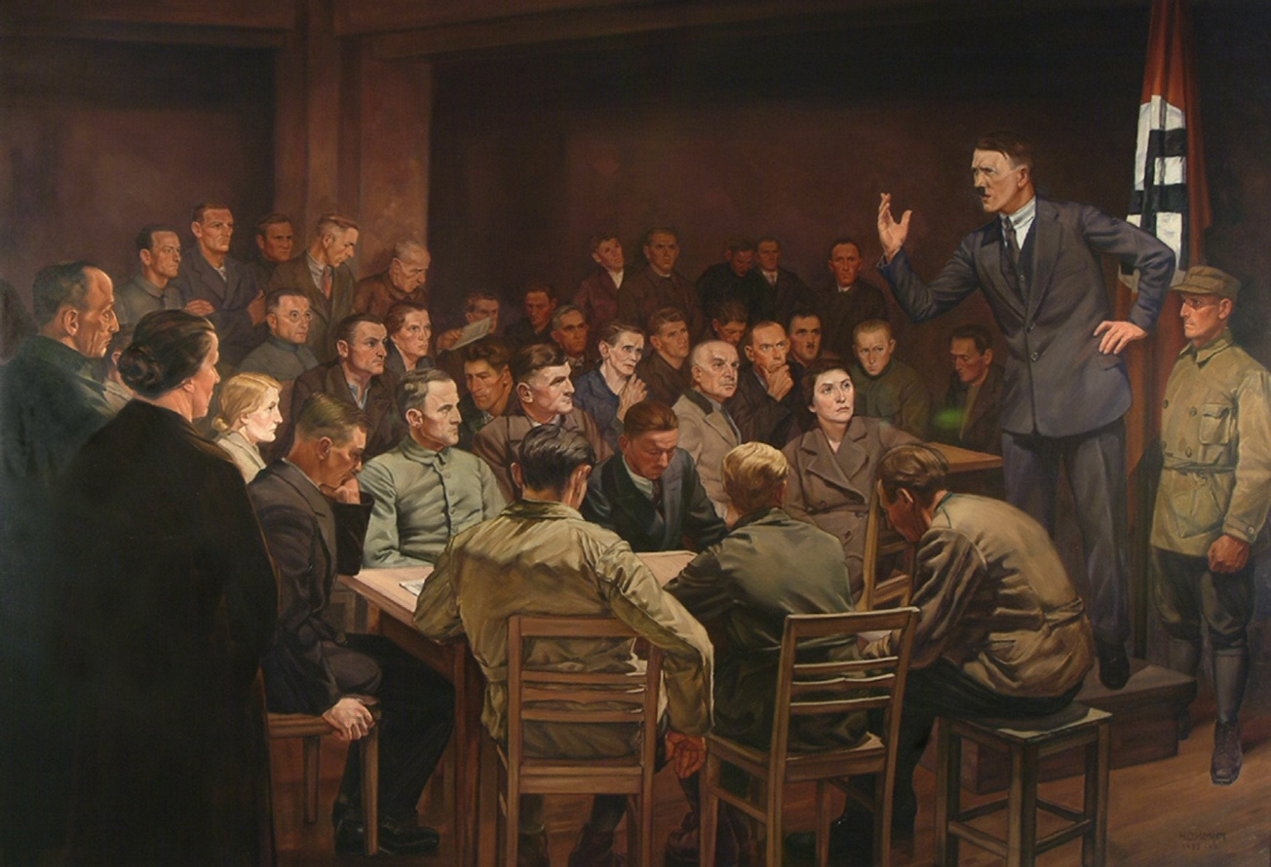

ANSWER:
- The source suggests
- Details that show this
- This source also suggests
- Details that show this

QUESTION 2: Explain why support for the Nazi Party increased in the period 1929-1933.
You may use the following in your answer:
- The Great Depression.
- The threat of the KPD.
You must also use information of your own.
[12 marks]

ANSWER:

QUESTION 3A: How useful are sources B and C for an enquiry into how Hitler came to power? Explain your answer, using sources B and C and your knowledge of the historical context.
[8 marks].
Source B: A 1933 cartoon from the British political magazine Punch. It shows Hindenburg on the left and Von Papen on the right, lifting Hitler to power.
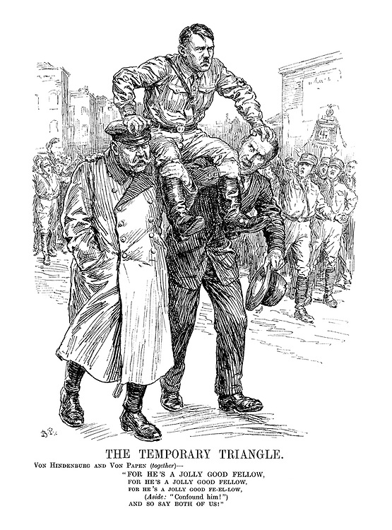

Source C: From Berlin Stories by Christopher Isherwood, published in 1945. Isherwood was a British journalist living in Berlin at the time Hitler came to power.

Each week there were new emergency decrees. Bruning’s weary episcopal voice issued commands… and was not obeyed… Berlin was in a state of civil war. Hate exploded… out of nowhere; at street corners, in restaurants, cinemas… at midnight… in the middle of the afternoon. Knives were whipped out, blows were dealt with spiked rings… cahir-legs or leaded clubs; bullets slashed the advertisements… In the middle of a crowded street a young man would be attacked… thrashed, and left bleeding on the pavement. “Bruning is weak” they said. “What these swine need is a man with hair on his chest”.

ANSWER:

QUESTION 3B: Study interpretations 1 and 2. They give different views about the way Hitler came to power. What is the main difference between these views? Explain your answer using details from both interpretations.
[4 marks]
Interpretation 1: From Weimar and Nazi Germany by Stephen Lee (1996).

… between 1929 and 1933 crisis returned in full force. Germany experienced a serious depression. This caused the collapse of businesses and an increase in unemployment. The moderate parties of the Weimar Republic could not agree… More use was made of Article 48. The Reichstag was bypassed. Democracy was replaced with dictatorship. A larger part of the population showed interest in Hitler’s ideas. The result was that the Nazis became the biggest party in the Reichstag. [They] gave Hitler power, hoping he would use it as they wanted.

Interpretation 2: From Nazi Germany 1930-39 by Steve Waugh and John Wright (2007).

Von Papen was determined to regain power. He met Hitler and agreed that Hitler would lead a government with Von Papen as the Vice-Chancellor. Intrigue took the place of open political debate. The landowners and leaders of industry were convinced that Von Papen and Hitler would save Germany. Von Papen said that he could control Hitler. On 30th January, Adolf Hitler became Chancellor of Germany.

ANSWER:

QUESTION 3C: Suggest why Interpretations 1 and 2 give different views about Hitler’s rise to power. You may use sources B and C to help you explain your answer.
[4 marks]
ANSWER:

QUESTION 3D: How far do you agree with Interpretation 1 about Hitler’s rise to power? Explain your answer, using both interpretations, and your knowledge of the historical context.
[16 marks]
ANSWER:

